Public Purchase – How a Vendor Places a Solicitation Response

Table of Contents

Public Purchase – How a Vendor Places a Solicitation Response
Responding to a Solicitation 2 – 5
Electronic Responses 2 – 5
Downloading and Responding to Documents 2 – 4
Submitting the Response 5
Editing a Response 5

How a Vendor Places a Solicitation Response

When you are ready to respond click on the title of the solicitation. On the right hand side you will have the option to Respond.

Click on Respond to bid
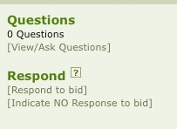

If there are any documents that the agency is requiring that you accept, you must click on [download] and open the document, and then fill out the required information. When saving the document it will be saved on your computer.
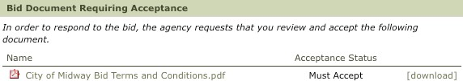

Answer the question by selecting one of the responses below.

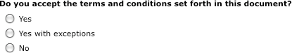

You will be asked to enter in your password after each document and question. Then click Save.

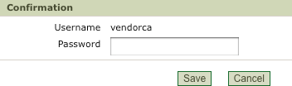

If there is more than one document that the agency is requesting, the next document will be shown. This will repeat until all documents are downloaded. Click on [download], open the document and fill out the information. When saving the document, it will be saved on your computer.

.

Enter your pricing directly on the website (if applicable). Use the additional fields for each line to enter appropriate information such as brand, model number, and any other information that is pertinent to the item you are bidding/proposing.

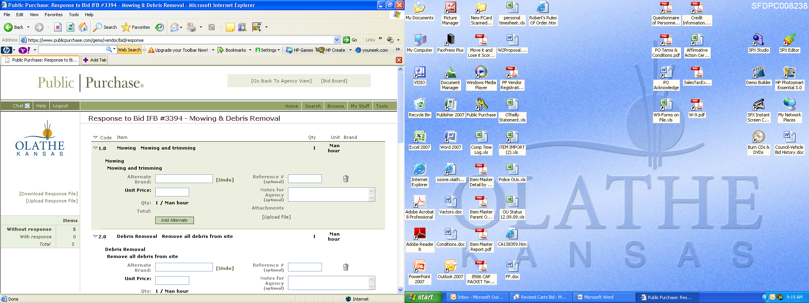

If there are any comments that you want to add to your response, you are welcome to add them at this time. Make sure you click Save Comment.

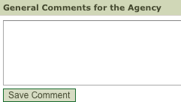

You will now need to upload the documents. Click on Upload File.

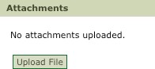

You will be shown the uploaded documents.

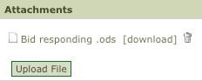

Depending on the type, you will be shown one of the two options. Both will immediately
submit your response.

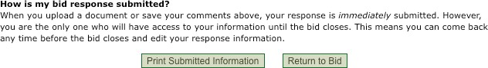

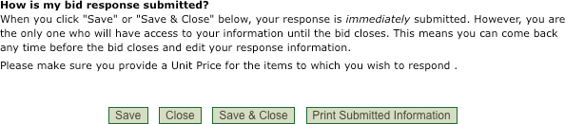

Your response has now been submitted. You can check this by returning to your Public Purchase. You will see the bid in the Bids Responding To section you will see the bid.

If you want to Edit your response prior to the ending time of the solicitation, you can click on the bid title and click on Edit Response to Bid.
